Item 31111005426034 has 2 hold requests

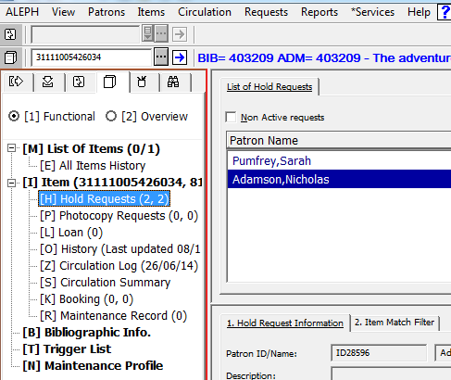

I you want to refuse a request do ...

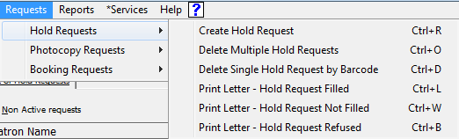

In the upcoming window type the item’s barcode

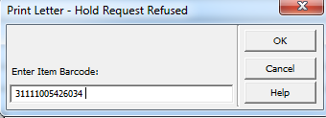
The „Refuse request“ window will open and you can select „Refusal“, „Print“ or „Expand“

